New Mexico Watercolor Society
Prospectus

Spring “Members Only” Watercolor Exhibition 2012

Entry Deadline  Entry Fees |  | Friday, April 6th, 2012  $15 for 1 painting, $30 for 2 paintings, $40 for 3 paintings (Maximum 3)
Juror/Judge  Exhibition dates |  | Betty Carr  May 11 - 27, 2012
Location |  | Albuquerque, New Mexico  EXPO New Mexico (NM State Fairgrounds), Fine Arts Building
Eligibility |  | Open to all NMWS Members
Questions |  | NMWS Exhibition Committee Chairperson  Toni Seidel: (505) 821-1791
Major Awards |  | Best of Show  First Award  Second Award  Third Award  (More awards to be announced) |  |  | $600  $500  $400  $300
Juror/Judge Qualifications |  |  | Calendar
Energetic, brightly colored still life’s are the signature work of Betty Carr. She is known for her skillful use of light and shadow in her floral paintings. “What catches my eye is the effect light has on form in unique situations.” Betty Carr is emerging as on of the foremost painters of the southwest. In Her book Seeing the Light – An Artist’s Guide, she shares her time-tested secrets for capturing the awe-inspiring qualities of light.  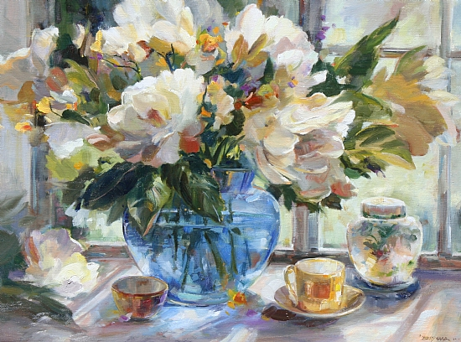  Betty Carr will conduct a four day (May 8 – 11) watercolor workshop prior to this years spring exhibition. Cost for members is $220. For information contact: Barbara McGuire bmcguire@swcp.com or (505) 235-1375 |  |  | Friday, April 6 | Entry deadline (emailed digital images and paper entries must ARRIVE by this date)
 |  |  | Friday, April 27 | Notification of accepted paintings mailed
 |  |  | Monday, May 7 at 7:00 PM  Tue – Fri, May 8 - 11 | Betty Carr - NMWS Meeting - Demo  4 Day Workshop by Betty Carr  Fine Arts Bldg, Expo NM
 |  |  | Friday, May 4 | Shipped Paintings Arrival Date to  Mail Bank, 1208 San Pedro NE, Albuquerque, NM 87110 c/o NMWS
 |  |  | Tuesday, May 8 | Hand-Delivered Paintings Received  Time: 12:00-2:00 PM  Location: Fine Arts Bldg, Expo NM
 |  |  | Wednesday, May 9 | Judging for Awards
 |  |  | Thursday, May 10 | Hang Show 12:00-4:00 PM
 |  |  | Friday, May 11 | Opening Reception 7:00-9:00 PM with Betty Carr
 |  |  | May 12 – 27 (Thursday – Sunday) | Exhibition Open to the Public  Thursday - Sunday 10 AM to 4 PM
 |  |  | Sunday, May 27 | Exhibit Closes at 4 PM  Pickup Paintings  Time: 4:00-5:00 PM  Location: Fine Arts Bldg, Expo NM  Paintings will not be released before 4 PM
Do you want to become a member of the New Mexico Watercolor Society?

You can download an application from our website, www.nmwatercolorsociety.org or contact us at:
New Mexico Watercolor Society Membership Chair,
PO Box 11604 Albuquerque NM 87192

Prospectus Revised 01/12/12

HOW TO ENTER
1 | CHOOSE YOUR PAINTINGS  (MAXIMUM 3) | - Entries must be original, entirely the work of the unsupervised entrant. Copies, prints and digitally produced materials of any kind are not allowed.  - Minimum image size is 80 square inches. Maximum image size is 30 x 38.  - Entries must have been completed within the last two years.  - Only works not previously accepted/shown in NMWS Spring or Fall Shows, Western Federation Shows, or MasterWorks of NM can be submitted.  - Acceptable work for juried exhibitions shall include aqueous material defined as transparent and opaque watercolors (gouache), acrylics, egg tempera, casein, watercolor pencils, crayons and water soluble ink. No water-based oils. Collage is acceptable using plain white papers painted with water-based media.  - Approved Papers and Supports:  - No pre-printed papers or embedded three dimensional objects will be accepted as part of a collage painting.  - All paintings shall be executed on approved paper. Approved paper is defined as cotton rag paper, cotton rag paper-mounted board, Yupo, watercolor canvas and Oriental papers. All other supports that are NOT approved include: clayboard, Masonite, canvas and wood.  - All finished artwork will remain unvarnished, framed and matted under Plexiglas.
2 | PHOTOGRAPH YOUR ENTRIES  WITH A DIGITAL CAMERA  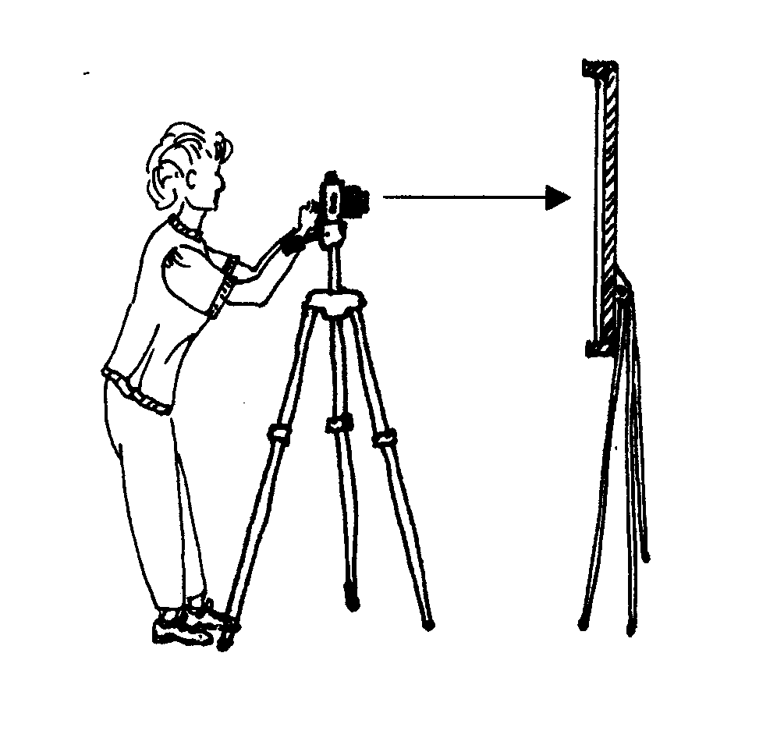  CROP AND SAVE THE IMAGES | Only digital entries of work will be accepted. (NO SLIDES) The juror will judge paintings by viewing digital entries only. If the image does not accurately represent the actual painting, your work will be rejected. You are encouraged to use a good digital camera (3.0 Mega Pixels or higher suggested). Please crop the image so only the painting is shown.  File format: JPG files (only), Printer Resolution: 300 dpi  Image size: maximum of 1200 pixels on the longest dimension.  Call the file manager for help in submitting digital entries.  File Name Convention: first 4 letters of last name, first 4 letters of first name, month and year of exhibit, A, B, or C for entry number. (If your first or last name has only 3 letters, add an 'x' to complete the four letters.)  For example if Jon Smith had 3 entries:  smitjonx0512A.jpg  smitjonx0512B.jpg  smitjonx0512C.jpg
3 | EMAIL IMAGES TO THE FILE MANAGER | Attach your digital entries to an e-mail sent to woodyduncan@comcast.net  Subject line should read: Digital Entries Smith (use your own last name)  In the e-mail please include your full name, address, phone number, e-mail address and also list the file names and the full title of the paintings you are attaching to that e-mail. You will receive a confirmation e-mail that your entries were received, or a request for appropriate corrections and re-submittal of your entries if prior to the deadline. Note: Painting titles are not to be more than twenty-five (25) characters including spaces.  If you have any questions about this process, email the file manager,  Woody Duncan at woodyduncan@comcast.net
4 | FILL OUT THREE FORMS  - Please print legibly.  - All blanks must be filled out.  - You may submit copied forms. | - Entry Form  - Notification Card  - Artist's Record of Entry
5 | WRITE YOUR CHECK | - $15 for 1 painting, $30 for 2 paintings, $40 for 3 paintings (Maximum 3)  - Make check payable to "New Mexico Watercolor Society"
6 | MAKE A RETURN ENVELOPE  (SASE) For notification of acceptance or non-acceptance of paintings into the Exhibition. | - #10 business/legal size (4-1/8 X 9-1/2") envelope  - Put postage for two ounces on the envelope  - Addressed to yourself
7 | ASSEMBLE ENTRY PACKET  Use Entrant's Checklist at right. | - Address envelope to: Woody Duncan, File Manager  7236 Calle Montana NE  Albuquerque NM 87113 (505) 344-3613  - Include: Entry Form, Notification Card, Check, and SASE.
8 | MAIL ENTRY PACKET DEADLINE | - Must be received by Fri, April 6, 2012, regular mail or hand-delivered.  - NO entries may be sent by Registered or Certified mail or requiring a signature: These are unacceptable and will be rejected at the entry level.  - NMWS is not responsible for late arriving entry packets.  - If possible, please send your entries early.

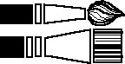
Fall 2012 ENTRY FORM
PRINT
Artist's Name _________________________________

Phone (H) _________________(W)_______________

Address _____________________________________

City/State/Zip _________________________________

Email address: ______________________________

Signature ____________________________________
(Submission to this exhibition constitutes acceptance and agreement on the part of the entrant to conditions and terms stated in this prospectus).

NMWS
Image A Title_________________________________

Image Size ____________________ Price _________

Filename of digital entry _____________________

Image B Title_________________________________

Image Size _____________________ Price _________

Filename of digital entry _____________________

Image C Title_________________________________

Image Size _____________________ Price _________

Filename of digital entry _____________________

NOTIFICATION CARD Spring 2012

Artist's Name ________________________________
PRINT
DECISION OF JUROR

Image a Title ________________________________

______Accepted _____Declined

Image B Title _______________________________

_____Accepted _____Declined

Image C Title _______________________________

_____Accepted _____Declined
Cut
Cut
ENTRANT'S CHECKLIST

The Entry Packet must include:
1. ______ Completed and signed entry form
2. ______ Filenames of the digital entries
3. ______ Completed Notification Card
4. ______ Cut Notification card from Entry Form before
enclosing.
5. ______ Non-refundable check made out to:
New Mexico Watercolor Society
$15 for 1, $30 for 2, $40 for 3 (3 maximum)
6. ______ SASE Return Envelope, with two stamps
7. ______ Address an envelope to:
Woody Duncan, File Manager

7236 Calle Montana NE
Albuquerque, NM 87113
8. ______ Seal and mail or hand deliver. Entries must be
RECEIVED by Fri., April 6, 2012
NO EXCEPTIONS PLEASE
9. ______ Fill out and keep Artist's Record of Entry
ARTIST'S RECORD OF ENTRY Spring 2012

______________________________________________
Image A Title
______________________________________________
Image Size Medium Price

______________________________________________
Image B Title
______________________________________________
Image Size Medium Price

______________________________________________
Image C Title
______________________________________________
Image Size Medium Price
REMINDER:
Entry forms (by US mail) and digital images (by email) must be RECEIVED by Fri April 6, 2012 to be eligible.

If an artist's painting is accepted into the show, the painting must be available for display or the artist will suffer an ineligibility penalty for future NMWS-sponsored shows for a period of two (2) years. The price of your painting cannot be changed after entry.

QUALIFICATION FOR SIGNATURE MEMBERSHIP
Signature status is obtained by applying to the Signature Membership Chairperson of the Signature Members Group (SMG) after a NMWS member has been judged in five (5) juried NMWS, WFWS or MasterWorks of NM shows within a 5 year period, with a limit of 2 shows per year. Artists accepted into any NMWS show must save the catalog from each show to present to the secretary verifying membership eligibility (refer to Guidelines).

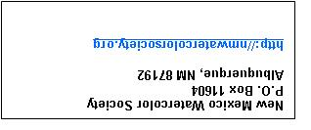
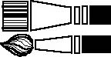

EXHIBITION DETAILS  LIABILITY  NMWS does not carry insurance on paintings submitted for competitive exhibitions; every precaution will be taken for the safety of your works. Artists must carry their own insurance. NMWS or its representatives will not be responsible for theft, loss, or damage of works submitted. NMWS is also not responsible for shipping delays.  USE OF PAINTINGS  Your signature on this entry form indicates your permission that, should your entry(ies) be accepted, a likeness of your work(s) may be displayed on the NMWS official website and/or used in promotional materials such as the show catalog and/or announcements for this and future exhibitions.  FRAMING  Framing must meet gallery quality standards. Accepted paintings must be framed in metal or wood, matted in white or off-white. Colored liners are acceptable. Plexiglas must be used on all accepted works. Mats must be clean with no debris between the Plexiglas and the mat. The wires must be of heavy-weight strength and peak at 3-1/2" below the top of the frame. Paintings not meeting these framing requirements will not be hung in the exhibit.  RIGHT OF REFUSAL  NMWS reserves the right to refuse any work that is damaged, improperly framed or fails to meet the entry requirements.  HAND DELIVERY OF ACCEPTED PAINTINGS  Deliver the accepted paintings to EXPO New Mexico (State Fairgrounds) at the location and times specified in this prospectus. Paintings not arriving on time will not be judged, and may not be hung. (No handling fee if hand delivered)  SHIPPED PAINTINGS  Paintings must be shipped to Mail Bank, 1208 San Pedro NE, Albuquerque, NM 87110 c/o NMWS. Shipped paintings must be received at least one day earlier than hand-delivered paintings. Late arriving paintings will not be judged and may not be hung. | Payment of handling: make checks payable to Mail Bank  - $45 per single painting in one package/box, plus  - $20 for each additional painting included in package/box, or  - $55 per crate containing one painting, plus  - $20 per additional painting in same crate  - A check for return shipping costs or pre-paid label.  RETURN OF PAINTINGS  All paintings must be picked up on the specified time, day, and location specified on the prospectus calendar. No painting will be returned before the end of the show to ensure proper record keeping.  STAFFING OF EXHIBITION  Accepted artists (living within 50 miles of the exhibit) are required to be the exhibition hosts. The hosts ensure the security of the paintings, provide information to visitors, request votes for the "People's Choice Award", and refer sales inquiries to artists during the exhibit. To schedule your "sitting time:”  1. Call the Gallery Host Coordinator specified in your acceptance packet to schedule a three-hour period of coverage during the hours the exhibit is open to the public (Thursday through Sunday only).  OR  - Pay a $25 fee if unable to schedule a time or find a substitute sitter. If coverage is not scheduled by the day set for receiving paintings, the $25 fee will be collected when the paintings are delivered.  SALES  Accepted paintings may or may not be for sale. The price cannot be changed after entry. The exhibit hosts will take checks from buyers made out to the artist. Checks will be mailed to the artists after the show closes. If your painting sells, a red dot will be placed on your painting in the exhibit. Buyers may pick up purchased paintings only after the exhibit closes.  DONATIONS  A tax-deductible donation, of 25% of the sales price, to the NMWS would be appreciated for any sold paintings. A receipt for all donations will be provided by NMWS.

